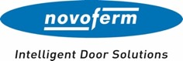

Press release
March 2025

70 years: Novoferm’s road to success
From a local metal and steel construction firm to an international brand

It all started 70 years ago in a workshop on the Lower Rhine. Today, with more than 3,500 employees and annual turnover of more than 700 million euros, the Novoferm Group is one of the leading system suppliers of door solutions as well as docking systems in Europe. In March 2025, Novoferm proudly celebrates its 70th anniversary.

From the early days to an international group of companies
The company – then known as Isselwerk Werth GmbH – was founded on the Lower Rhine on 10 March 1955. Over the decades, what started as a local metal and steel construction firm developed into an internationally operating group of companies, which has belonged to the Japanese Sanwa Group since 2003. In addition to continuous technological further development, Novoferm relies on strategic acquisitions to reinforce its market position. One example of this is the takeover of the Dutch industrial door manufacturer Alpha Deuren in 2014, which enabled to the company to greatly expand its international position in this segment. Today, Novoferm manufactures in many locations in Europe and markets its products all over the world through many national companies and sales partners.

Innovation and digital solutions as factors for success
Over the last decades, Novoferm has expanded its product range with innovative and customer-oriented solutions. The most recent new products include a powerful operator system with DC technology that offers clear time savings during the assembly and commissioning of industrial doors. Moreover, in 2024, Novoferm expanded its range of doors, which meet practically all of the requirements of modern commercial buildings, with the steel tubular frame doors NovoFire Steel, developed and manufactured in-house. What’s more, since 2022 the range has included the Evolution premium sectional doors for private garages with particularly high heat insulation. Thanks to the thermal break between the outer and inner skins, the heat insulation achieved with the door can be up to 17 per cent better than with comparable sectional garage doors. When combined with garage doors, fast garage door operators, including the new generation of the side operator NovoPort Speed – another unique feature of Novoferm, are a highlight for private developers and renovators. In addition to continuous product innovations, which, among other things, contribute to simplification and energy efficiency, Novoferm is specifically investing in digitalising its services. Digital tools that are exactly tailored to the needs of various target groups, offer architects, planners, site managers, technician, fitters and facility managers along the whole process chain the perfect solutions for every customer phase. This increases efficiency and safety and optimises work processes.

Strategic acquisitions and milestones of then last decade
In the last ten years, Novoferm has aimed for strong strategic growth. With targeted takeovers, the company has further expanded its presence in important European markets: For example, in 2016 Novoferm acquired the Norsud Group, a leading provider of industrial doors and docking technology on the French market. Another milestone in the same year was the opening of the over 1,000 sqm training and technology centre in Dortmund. The modern location is both a further training site for employees, partners and customers as well as a showroom for familiar and new product solutions. Moreover, in 2019 the Swedish steel door manufacturer Robust AB, a leader in Scandinavia and the UK, was taken over. In 2021, the French Manugestion Group, specialised in the installation, maintenance and repair of industrial doors and docking systems, followed. In this way, Novoferm strengthened its service focus and its expertise as a supplier of industrial solutions.

Looking ahead
For its 70th anniversary, Novoferm is not only looking back on a successful past, but also with anticipation to the future. The years ahead will be marked by innovative technologies and digitalisation. As part of a new direction, a generation change has taken place in the management in the last few months. Christian Hasenest has been gradually taking over the position of CEO from Rainer Schackmann and will steer the company into the future with new approaches. “In the last few decades, Novoferm has achieved a great deal – we can all be proud of that. I am looking forward to continuing this tradition together with our team and, at the same time, setting new priorities to make our company fit for the challenges of the future,” Hasenest said.

Characters (including blank spaces): 4,747

About Novoferm
Novoferm is one of the largest European system suppliers of hinged door and garage door solutions as well as docking systems for private, commercial, and industrial use. The company was established in 1955 in the Lower Rhine as Isselwerk Werth GmbH and has been part of the Japanese Sanwa Group (owned by the Sanwa Holdings Corporation) since 2003. The Novoferm Group has production plants in various European locations and sells products in many countries worldwide through a number of subsidiaries and sales partners. Novoferm employs over 3,500 people and is certified in accordance with DIN EN ISO 9001.

Images:

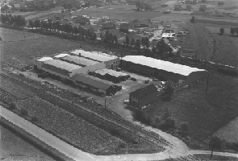

The original company headquarters: the plant in Isselburg-Werth in 1963. Nowadays, some 400 production and administration colleagues work here. Up-and-over garage doors and steel frames are manufactured on a hall area of 45,000 sqm in the highly automated production facilities. (Photo: Novoferm)

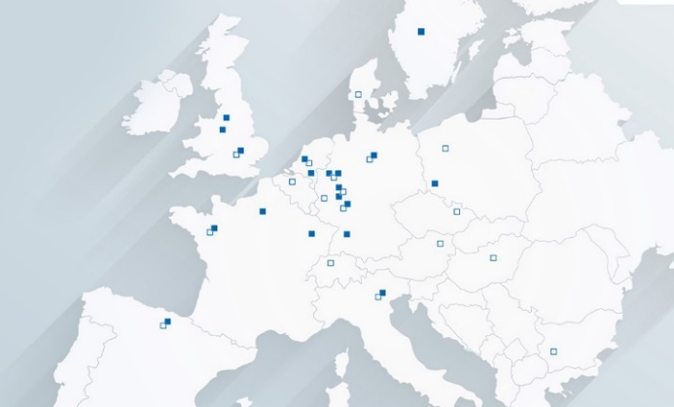
From small beginnings in Isselburg-Werth to an international solution provider for door and door solutions as well as docking and logistics systems with many production locations and own sales companies all over Europe. (Photo: Novoferm)

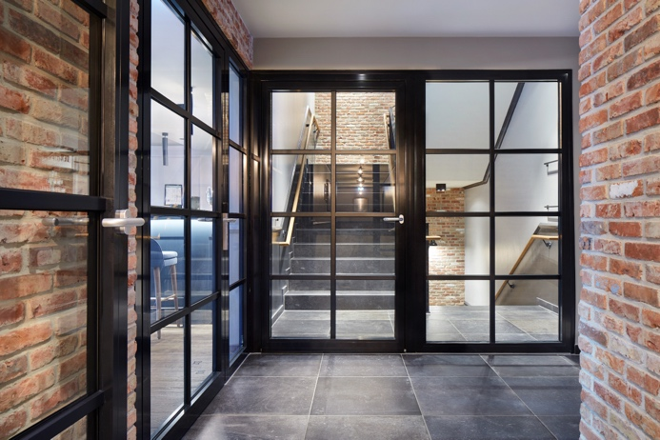
Elegant and flush: With NovoFire Steel in 2024, Novoferm launched the first steel tubular frame door developed and manufactured in-house that is licensed as a fire-resistant and smokeproof seal. The new flush doors offer many design options and are simple to fit. (Photo: Novoferm)

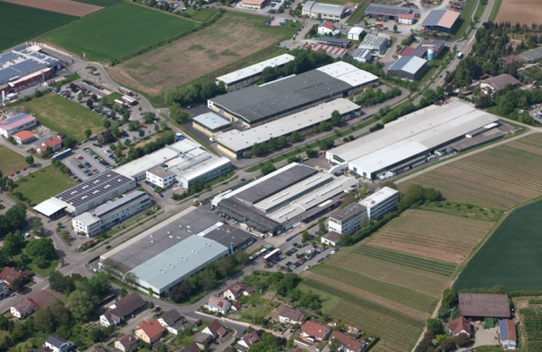
At the Brackenheim site Novoferm manufactures the high-quality NovoPorta Permio and NovoPorto Plana on an area of 32,000 sqm; as multifunctional doors they meet many requirements, such as fire, smoke and burglary protection and noise insulation. (Photo: Novoferm)

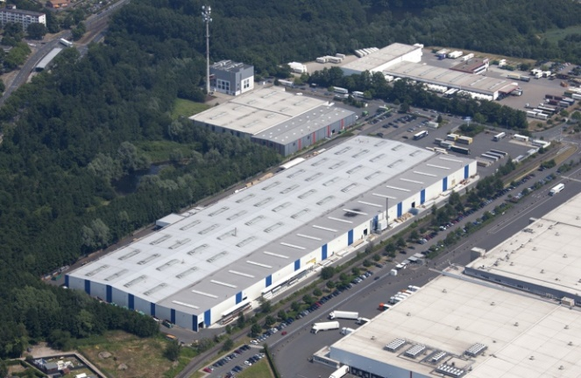
In the ultramodern plant in Dortmund, Novoferm manufactures sectional garage doors on an area of 30,000 sqm. Operator and control systems for garage doors and industrial applications are developed and manufactured at another site in Dortmund. (Photo: Novoferm)

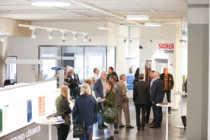
The training centre with its integrated showroom and adjacent test and technology centre at the Dortmund site is very popular. Here, visitors can get to know the extensive range of products and services from the Novoferm Group over more than 1,000 sqm. (Photo: Novoferm)

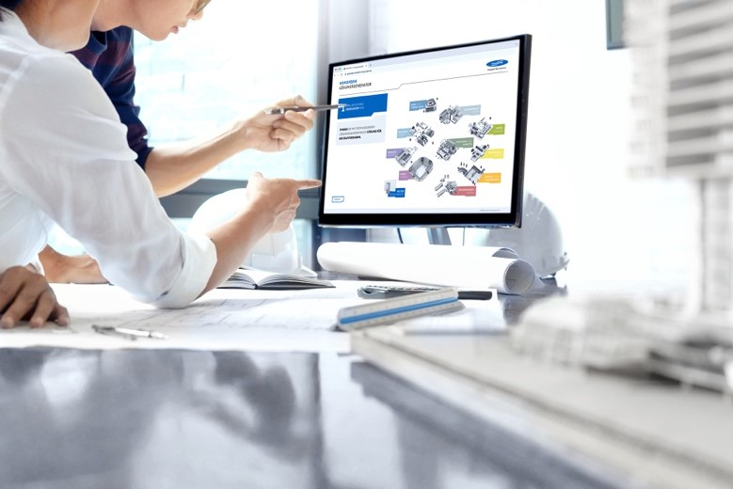
An example of digitalisation: With the help of the Novoferm solution generator, planners, architects and industrial customers can quickly and easily generate suitable product recommendations for specific building projects at the very early planning phase and draw up a first rough cost estimate. (Photo: Novoferm)

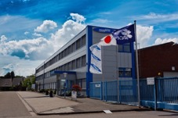
Today’s Novoferm company headquarters, one of the biggest European system suppliers of doors and door solutions as well as docking systems, is in Rees on the Lower Rhine. From here, for decades the company has been making history that is shaped by pioneering products, growth and international success. (Photo: Novoferm)

The text along with high-resolution images and other information is available at www.novoferm.de/presse and https://presseportal.brandrevier.com/kunden/novoferm/
.

Publisher Editorial contact
Novoferm Vertriebs GmbH Brandrevier GmbH
Press contact: Heike Verbeek Isabelle Sprang
Schüttensteiner Straße 26 Kettwiger Straße 2-10
46419 Isselburg (Werth) 45127 Essen
Tel.: +49 28 50 9 10-4 35 Tel.: +49 201 87 42 93-18
E-mail: heike.verbeek@novoferm.de E-mail: sprang@brandrevier.com
www.novoferm.com

